Test Case: tc006_SPX_Dev5_Crear_Requisicion_Spot_Tipo_Cobro_Proyect_Urgent
Step 1 - Enter username and password and click to button Enter: Credentials Entered
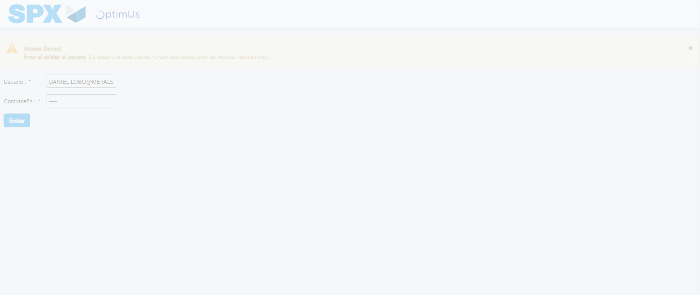Image file-name: QC_Testing-tc006_SPX_Dev5_Crear_Requisicion_Spot_Tipo_Cobro_Proyect_Urgent-1784215007800

Step 2 - Select to UEN and Access to Spot Buy Requisitions : UEN Correctly selected and Correct access
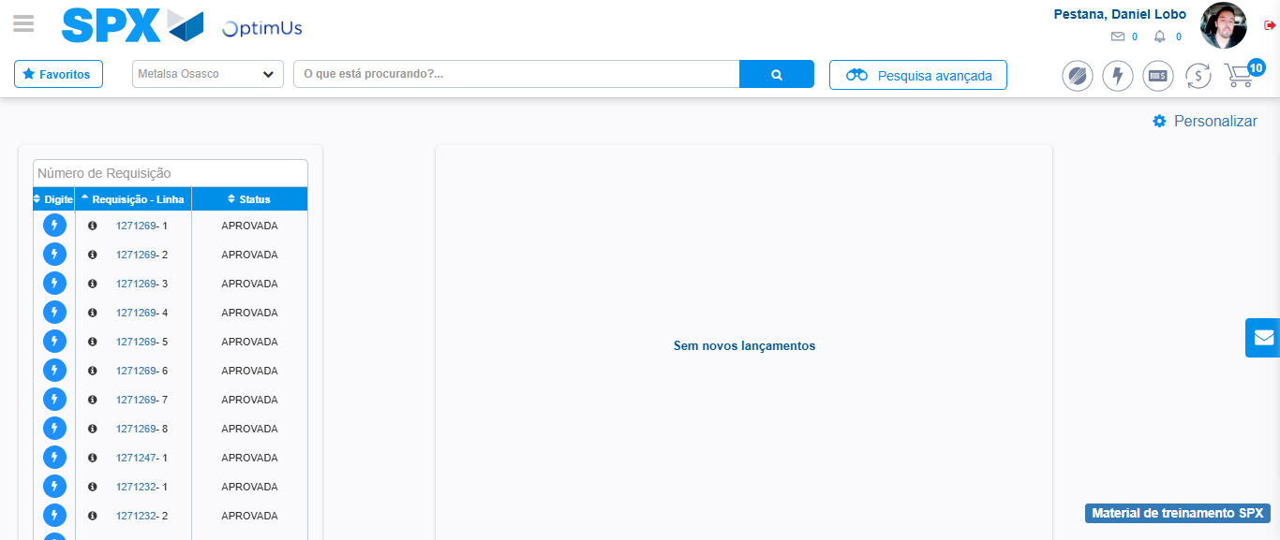Image file-name: QC_Testing-tc006_SPX_Dev5_Crear_Requisicion_Spot_Tipo_Cobro_Proyect_Urgent-1784215034020

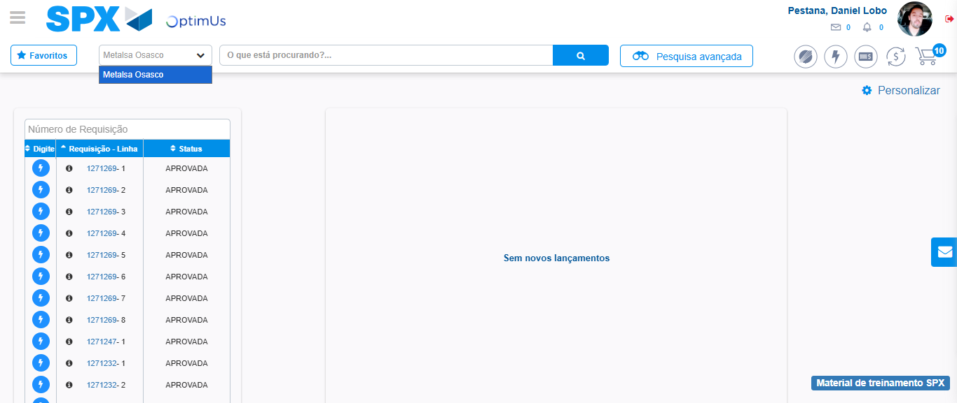Image file-name: QC_Testing-tc006_SPX_Dev5_Crear_Requisicion_Spot_Tipo_Cobro_Proyect_Urgent-1784215036695

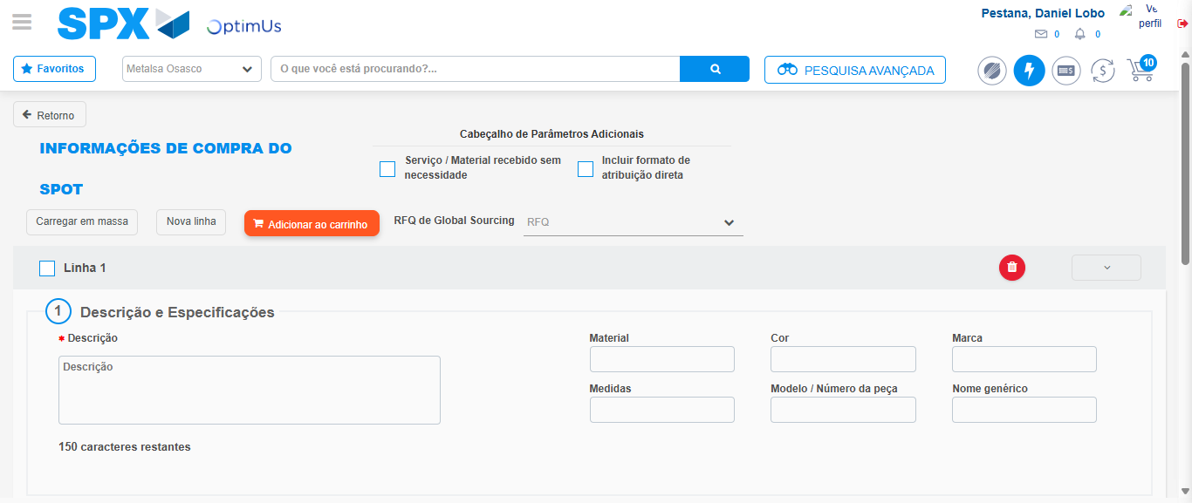Image file-name: QC_Testing-tc006_SPX_Dev5_Crear_Requisicion_Spot_Tipo_Cobro_Proyect_Urgent-1784215057613

Step 3 - Data Capture Spot Buy Requisition: Data captured correctly
Image file-name: QC_Testing-tc006_SPX_Dev5_Crear_Requisicion_Spot_Tipo_Cobro_Proyect_Urgent-1784215057883

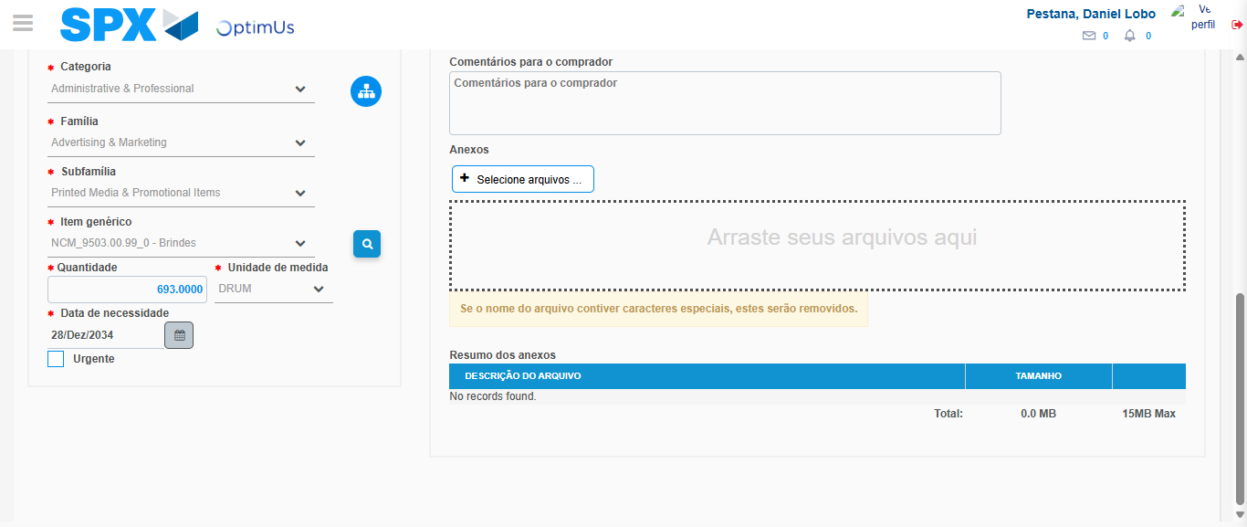Image file-name: QC_Testing-tc006_SPX_Dev5_Crear_Requisicion_Spot_Tipo_Cobro_Proyect_Urgent-1784215071125

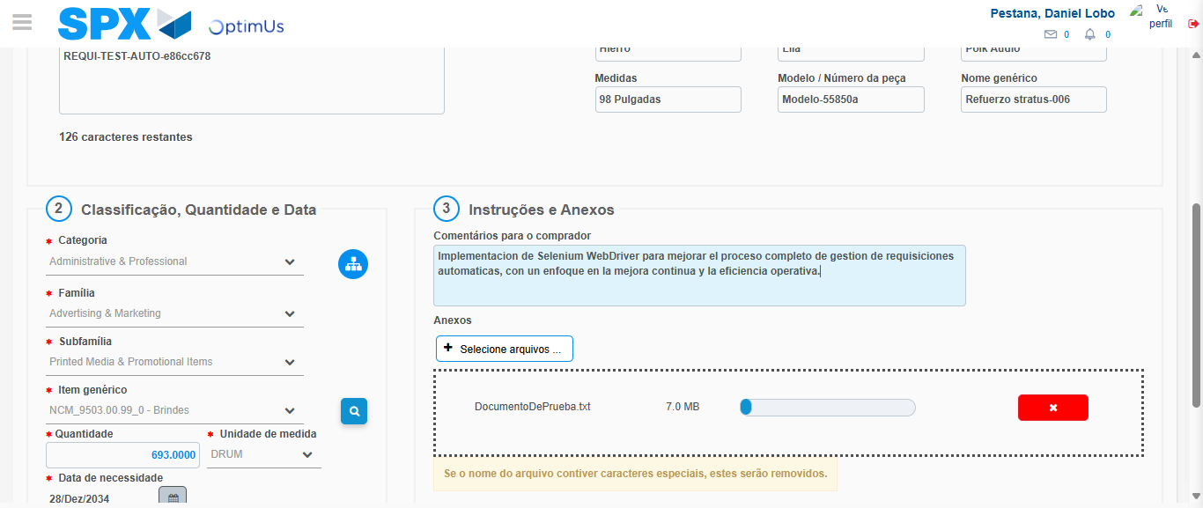Image file-name: QC_Testing-tc006_SPX_Dev5_Crear_Requisicion_Spot_Tipo_Cobro_Proyect_Urgent-1784215072112

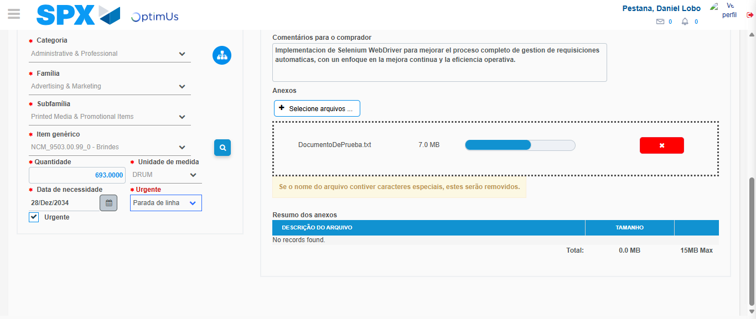Image file-name: QC_Testing-tc006_SPX_Dev5_Crear_Requisicion_Spot_Tipo_Cobro_Proyect_Urgent-1784215076098

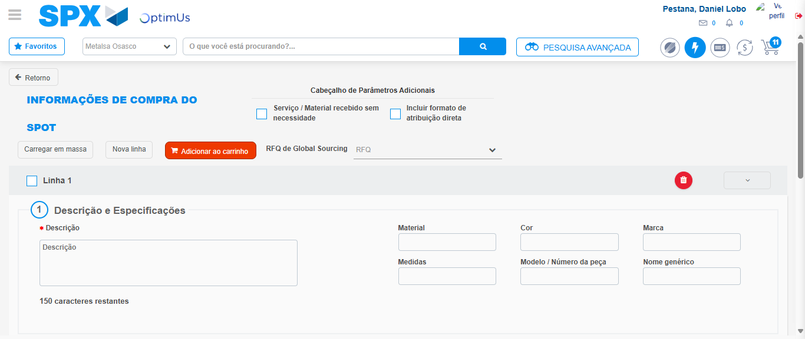Image file-name: QC_Testing-tc006_SPX_Dev5_Crear_Requisicion_Spot_Tipo_Cobro_Proyect_Urgent-1784215082467

Step 7 - Return to Main Page SPX : Return to Main Page SPX
Image file-name: QC_Testing-tc006_SPX_Dev5_Crear_Requisicion_Spot_Tipo_Cobro_Proyect_Urgent-1784215034020

Image file-name: QC_Testing-tc006_SPX_Dev5_Crear_Requisicion_Spot_Tipo_Cobro_Proyect_Urgent-1784215036695

Image file-name: QC_Testing-tc006_SPX_Dev5_Crear_Requisicion_Spot_Tipo_Cobro_Proyect_Urgent-1784215057613

Image file-name: QC_Testing-tc006_SPX_Dev5_Crear_Requisicion_Spot_Tipo_Cobro_Proyect_Urgent-1784215084734

Image file-name: QC_Testing-tc006_SPX_Dev5_Crear_Requisicion_Spot_Tipo_Cobro_Proyect_Urgent-1784215084940

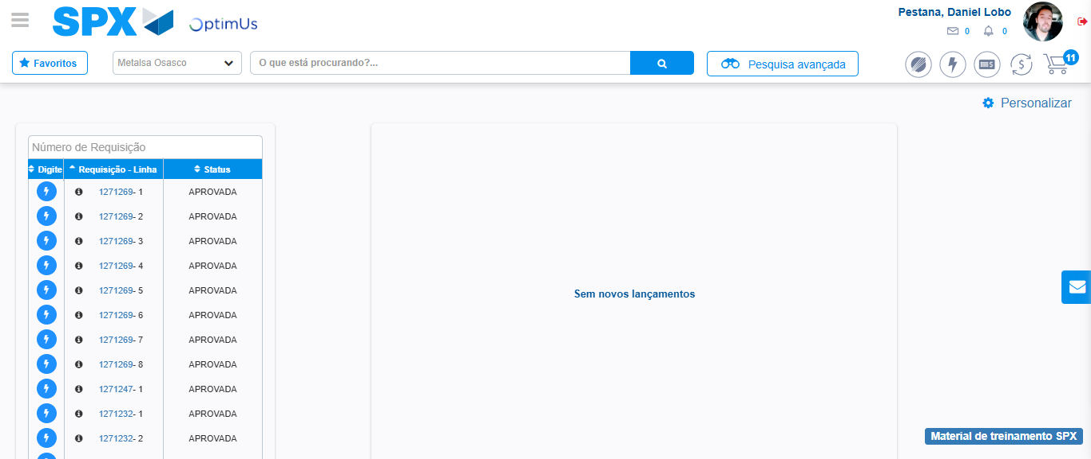Image file-name: QC_Testing-tc006_SPX_Dev5_Crear_Requisicion_Spot_Tipo_Cobro_Proyect_Urgent-1784215106088

Step 8 - Log Out : Log Out SPX
Image file-name: QC_Testing-tc006_SPX_Dev5_Crear_Requisicion_Spot_Tipo_Cobro_Proyect_Urgent-1784215106299

